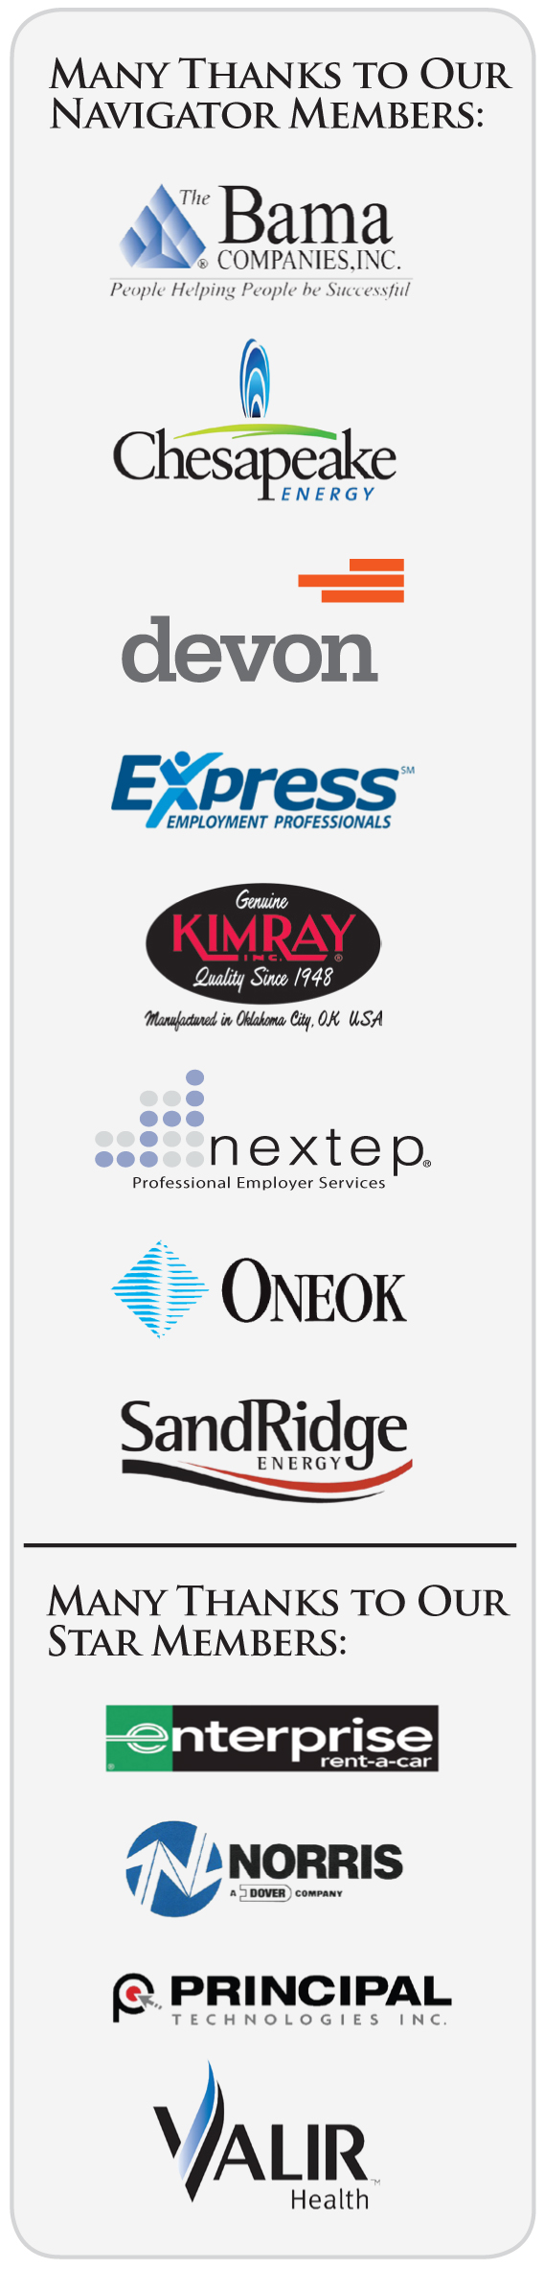
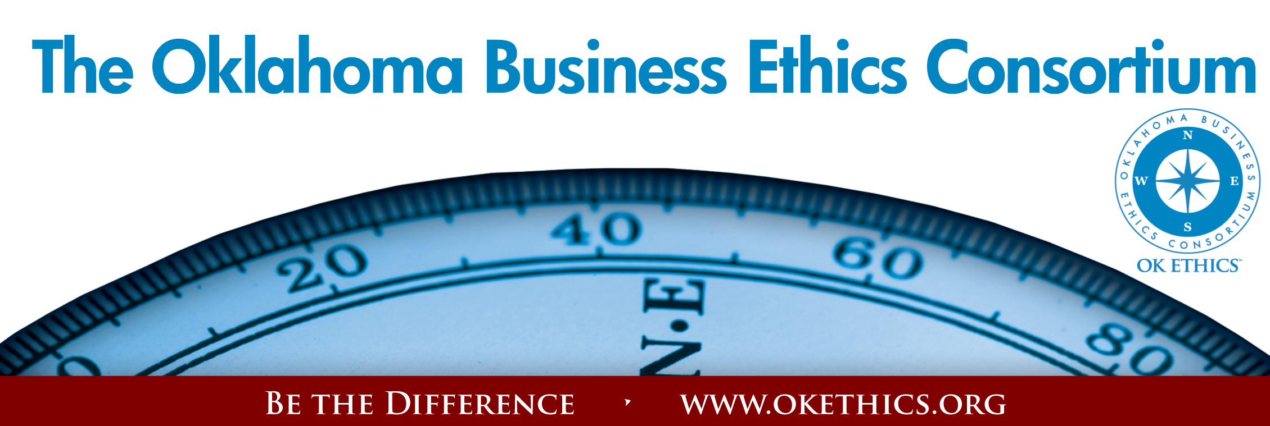
Agenda ~ Oklahoma City Chapter
November 12, 2008

- KUDOS & WELCOME Bob Byrne, Ethics Advisor, Boeing
President, OkEthics Foundation

  - Greg Byers of Sinclair Broadcasting Group – With a conscientious eye for detail and strong sense of responsibility, we are fortunate to have Greg’s ongoing leadership as Registration Chair.
  - Mary Kay Huggard & the Principal Technologies team consistently demonstrate a welcoming attitude and great service to all our members. Registration team members include: Lisa Laughlin, Holly Carattini, Kara Argo, Jennifer Hicks, and Ashley Warner.
  - Joshua Jantz of the Institute of Basic Life Principles takes on a big job by diligently preparing our name tags. We rely on him every month.
  - Bobby Redinger – Cole & Reed for her generosity in providing today’s agendas.
  - Kelli Schneider of Full Force Marketing & Brand Development for our OK Ethics commemorative magazine – available on our website at www.okethics.org or at the registration table. Kelli also designed our new agenda template.
  - Brent Gooden of The Gooden Group for his enduring friendship to OK Ethics and arranging today’s program.
  - Have you met Deborah Gavula, our new administrative support contact? She will be handling OkEthics billing and other administrative duties. Deborah can be reached at 889-0498.
  - Behind the scenes, our dedicated volunteers who serve on the Board and are the heart of this organization!

- LEADERSHIP & INTEGRITY
Video from www.walkthetalk.com
Discussion Questions:

- Who do I impact as a leader?

- Who (business leader) has had the greatest influence on my career?

3) What qualities did he/she have that I want to emulate?

4) How can I model those in my own workplace?

OK Ethics Guiding Principles (Please view our website for extended version.)
Lead with Integrity
- Dependability:
  - Members are asked to demonstrate their support of this initiative by consistently attending meetings.
- Initiative:
  - Recruiting other members who have demonstrated a desire to promote ethical behavior in their organizations.
  - Recognizing what needs to be done to help promote the Mission of the Consortium and taking action to assist in that effort.
- Honor:
  - Members are asked to honor the Consortium through the practice of integrity and ethical behavior in their business dealings.
  - We express gratefulness to our hosts, sponsors and speakers.
  - Realizing that each of us is in a mode of continual learning, we demonstrate humility, care and compassion when sharing our thoughts and knowledge.
- Courage:
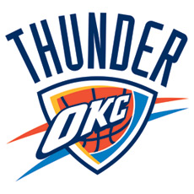
  - Speak the truth with confidence and encourage others to do the same.
- KEYNOTE
  - Introduction by Brent Gooden, The Gooden Group
  - Keynote by Sam Presti, General Manager of the OKC Thunder

IV. UPCOMING EVENTS Shannon Warren, Founder, OkEthics
Advance reservations required for all events ~
Visit our website at www.okethics.org or call 858-2233;
Member discounts apply regardless of location.
Moore-Norman- South OKC:
November 19 –
Brian Gabbard, CEO of Gabbard & Company
“Ethically Managing Change Through a Downturn”

⬅ RECOMMENDED FOR 1 CPE ⬇

OKC Chapter
December 10 –
“Healthy Ethics: Hospital Execs Discuss Diagnosis and Treatment of Ethical Dilemmas”

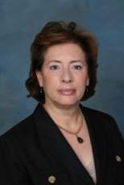 | 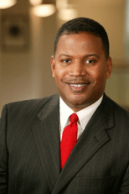 | 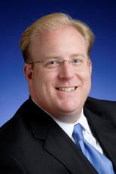 | 
Cathryn Hibbs  CEO  Deaconess Hospital | James Moore  President  INTEGRIS Canadian Valley Regional Hospital | Garyl Geist  President & CEO  Valir Health | Tom Rice  President  Southern Plains Medical Group

OKC Programs (Cont’d)

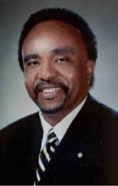
March 11 – Clifton Taulbert, President of The Building Community Institute
Taulbert is one of America's leading thought-leaders on the "Power of Community" and views community in the workplace as a powerful leadership asset. Taulbert was chosen by CNN at the turn of the millennium to represent one of the voices of 'Community.' Taulbert, a Pulitzer nominated author speaks throughout the world on the critical issue of building community, a set of emotionally satisfying relationships, within all the places of our living...creating an environment branded by Respect, Affirmation and Inclusion.
Taulbert is also the author of the internationally acclaimed book, Eight Habits of the Heart, a book that provides the framework on which to build, maintain and sustain a powerful, effective and caring Community. He believes the Eight Habits of the Heart are essential for developing leadership and he conveys this message to audiences around the world.
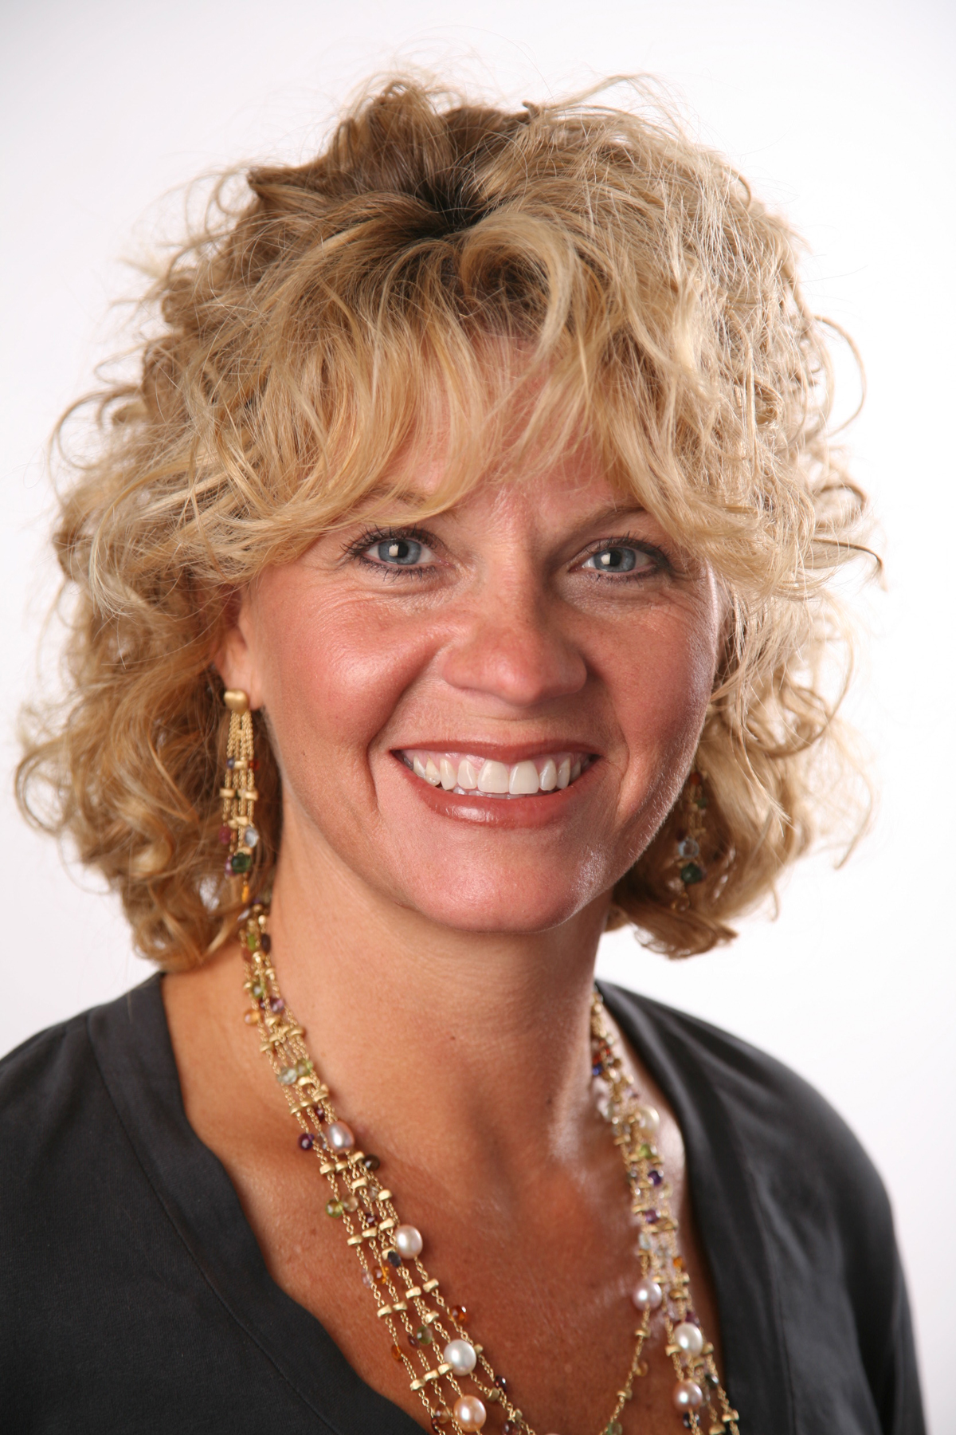

April 29 – OU Coach, Sherri Coale –
OkEthics Statewide Compass Awards (OKC)

Tulsa Chapter

November 20 – “Crisis Communication: The Ethics of Conflicting Voices” - A four-member panel representing the fields of law, media, litigation communication, and PR will lead us through two crisis case studies. We will explore the ethics of communication decisions and the pressures a business owner/leader faces (and the counsel he/she receives) from multiple perspectives during a crisis.
Guest panelists:
▪ Jeff Hassell, partner with Gable&Gotwals law firm
▪ Joe Worley, executive editor for the TulsaWorld
▪ Barrett Waller, APR, president of Waller & Company
▪ Darrean Browning, assignment manager from NewsChannel 8 KTUL
December 11 – Steve Burrage, State Auditor & Inspector

- OTHER RELATED PROGRAMS:

OK Ethics is honored by our friendship with the Character First! Institute. They provided wisdom and the basis for our Guiding Principles. For more information on their upcoming Oklahoma City Business and Community Leaders' Luncheon, please contact them at 815-0001, or visit www.characterok.org./

For more events and information about OkEthics, please visit our website at www.okethics.org
See also additional sponsors listed on our website.
PLEASE HELP US CONTROL COSTS BY LEAVING YOUR NAME TAG HERE!

